Advanced Algebra Last Practice Final

1) (5x+1)(-2x+9) =

2) Factor x² – 2x – 24

3) Factor x² + 12x + 10

4) Find the roots of the quadratic x² + 4x – 5 by factoring

5) If the roots of a quadratic are 3/5 and -2/3, what is the original quadratic?
Hint: convert the roots into factors then multiply the factors.

6) Find x if 2x² – 3x – 8 = 2

7) Solve (4 + i)(3 – 8i)

8) Factor 90m⁵n¹⁵ + 50m⁸n⁷ – 20m¹⁰n⁹

9) Rewrite using completing the square: x² + 8x + 21

10) Find the vertex for x² – 10x + 23

11) Graph x² + 2x + 5 on a separate piece of graph paper

12) Rewrite 12^{x} = 95 in logarithmic form

13) Solve for m if 8^{m} = 62

14) If you invest $925 at 6% compounded annually, how many years before you have $5000?

15) Find the horizontal asymptote for $\frac{{7x}^{5}-10x}{{11x}^{3}-9}$

y =

16) Find the vertical asymptotes for $\frac{x-1}{x^{2}+8x+12}$

x = ; x =

17) If p(traveling to New Mexico) = 0.417 and p(traveling to Arizona) = 0.328 what is p(traveling to both states)?

18) Given the probabilities in #17, what is the probability of traveling to New Mexico OR Arizona?

There is a 63% chance you will go to college. If you do, there is a 57% chance you will move out on your own, otherwise there is only a 26% chance you will move out on your own.

19) What is the probability that you will move out on your own?

20) What is the probability you will not go to college or you will be living at home?

1) (5x)(-2x) = -10x²; (+1)(-2x) = -2x; (5x)(+9) = +45x; (+1)(+9) = +9; -2x + 45x = +43x
-10x² + 43x + 9
2) (x-6)(x+4). Note: (-6)(+4) = -24 and -6 + 4 = -2
3) CBF. The factor pairs of +10 are 10+1 = 11 and 5+2 = 7. Neither of those add up to 12.
4) (x+5)(x-1) 0.5 points; Change the signs to get -5; +1 full point
5) If a root is $\frac{m}{n}$ then the factor is (nx-m). If a root is $-\frac{m}{n}$ then the factor is (nx+m). 3/5 => (5x-3) -2/3 => (3x+2) 0.5 points; (5x-3)(3x+2) = 15x² + x – 6 full point
6) Set equal to zero by subtracting 2 from both sides 2x² – 3x – 10 = 0 0.25 points; Use the quadratic formula $\frac{3 ± \sqrt{89}}{4}$ 0.5 points; $\sqrt{89}$ = 9.43 so the two roots are (3+9.43)/4 = 3.1075 and (3-9.43)/4 = -1.6075 full point
7) (4)(3) = 12; (4)(-8i) = -32i; (+i)(3) = +3i; (+i)(-8i) = -8(i²) = -8(-1) = +8
12 + 8 = 20; -32i + 3i = -29i => 20 – 29i
8) GCF(90, 50, 20) = 10; For variables the GCF corresponds to the lowest power GCF(m⁵, m⁸, m¹⁰) = m⁵; GCF(n¹⁵, n⁷, n⁹) = n⁷
Using the rule ${b^{c}}/{b^{d}}$ = $b^{c-d}$ we get 10m⁵n⁷(9n⁸ + 5m³ – 2m⁵n²)
9) The linear coefficient is +8. Half of that is +4 so the “square” part is (x+4)².
(x+4)² = x² + 8x + 16; 16 + 5 = 21 so “completing” the square needs +5
(x+4)² + 5
10)
Method 1: Complete the square like #9 to get (x-5)² – 2
Change the sign of the square part but not the complete part. V = (5, -2)
Method 2: The x coordinate of the vertex (V_{x}) = $\frac{-b}{2a}$ so V_{x} = $\frac{-(-10)}{2(1)}$ = 5. Now substitute 5 in for x in the quadratic (5)² – 10(5) + 23 = 25 – 50 + 23 = -2. V = (5, -2)
11) If you realize the vertex is (-1, 4) your job is a lot easier.
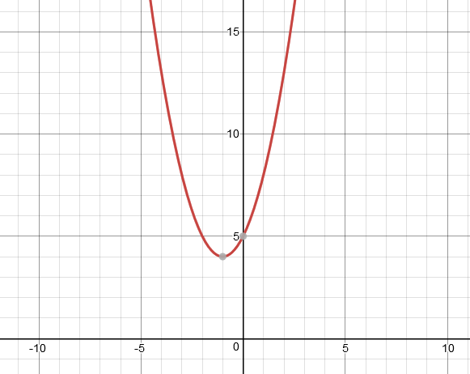
12) a = b^{x} => log_{b}a = x
log₁₂95 = x
13) a = b^{x} => ${ln⁡(a)}/{ln⁡(b)}$
1.9847
14) 29 years
15) The degree of the numerator is bigger than the degree of the denominator so there is no horizontal asymptote
16) The roots of the denominator are -6 and -2 so the vertical asymptotes are x=-6 and x=-2
17) NM and AZ = 0.417 x 0.328 = 0.136776
18) NM or AZ = 0.417 + 0.328 – NM and AZ = 0.608224
For 19 & 20
0.63 x 0.57 = 0.3591
0.57
Moving out

0.63 x 0.43 = 0.2709
NOT Moving out
0.63
Going to college
0.43

0.37 x 0.26 = 0.0962
0.26
Moving out

NOT going to college
0.37

0.74
NOT Moving out
0.37 x 0.74 = 0.2738

19) 0.3591 + 0.0962 = 0.4553
20) 0.2709 + 0.0962 + 0.2738 = 0.6409

